**Modeling the evolution of the U.S. opioid crisis for national policy development**

**Short title** (40 characters including spaces): Modeling the evolving U.S. opioid crisis

**One sentence summary** (125 characters including spaces):

A dynamic model evaluating shifts in opioid initiation and overdose rates projects potential future declines in mortality.

# Abstract

The opioid crisis is a major public health challenge in the United States, killing about 50,000 people in 2019 alone. Long delays and feedbacks between policy actions and their effects on drug use behavior create dynamic complexity, complicating policy decision making. In 2017, the National Academies of Sciences, Engineering, and Medicine called for a quantitative systems model to help understand and address this complexity and guide policy decisions. Here we present [OSM], a dynamic simulation model developed in response to that charge. Using data on opioid use, misuse, treatment, and overdose spanning 1999-2019, we highlight how risks of drug use initiation and overdose have evolved in response to supply-side changes, behavioral risk responses, and the competing influences of illicit fentanyl and overdose prevention efforts. These estimates yield a more nuanced understanding of the historical trajectory of the crisis, providing a basis for projecting future scenarios and informing policy planning.

# Introduction

The opioid crisis is a major public health problem in the United States, with half a million opioid overdose deaths in the last 20 years (*1*). Deaths have risen rapidly since 2014, with nearly 50,000 in 2019 alone (*2*), driven in part by the continuing illicit spread of fentanyl and other deadly synthetic opioids (*3*, *4*). Millions of people now suffer from opioid use disorder, with severe health, social, and economic consequences.

There are many potential policy levers government actors can use to address the opioid crisis, such as regulating approvals of prescription opioid analgesics or treatments for addiction and overdose, controlled substance scheduling and enforcement, and shaping medical and insurance practices around pain and addiction treatment. However, the net effects of these policy levers on the crisis and public health more broadly are often unclear. The opioid crisis acts as a complex adaptive system, with dynamic and nonlinear interactions between prescription opioid misuse, heroin/fentanyl use, overdose mortality and more (*5*). As a result, policy decisions based on past patterns of behavior may lead to unintended consequences as those patterns evolve over time (*6*, *7*). In addition, data on the crisis are limited and lagged, with large uncertainties even in basic quantities and parameters such as the numbers of people using heroin/fentanyl and the hazard rate of developing opioid use disorder (*8*).

Better policy planning requires grappling with these complexities and uncertainties, as well as a deeper understanding of the underlying dynamics of the crisis. Recognizing these needs, the National Academies of Sciences, Engineering, and Medicine (NASEM) in 2017 recommended that the U.S. Food and Drug Administration (FDA) develop an integrated decision-making framework for policy decisions, based on a system-level quantitative model of the opioid crisis (*5*).

Here we present [OSM], a data-driven simulation model developed in response to these recommendations. [OSM] improves on existing models of the opioid crisis in several ways.

First, [OSM] highlights the role of feedback mechanisms, such as social influence or risk perceptions (*9*, *10*), in shaping the evolution of the crisis. It combines these feedbacks with policy-relevant operational details on the impacts of synthetic opioids, fatal overdose prevention measures, and addiction treatment, to elucidate how and why patterns of risk have changed over time.

These risks, e.g., hazard rates of initiation or overdose, are not static, but change endogenously as the crisis evolves. Most existing national-level models of the opioid crisis (*11*–*13*) do not account for these changing hazards, or do so only exogenously, impeding their ability to make realistic projections of future trends. The one published model that incorporates key feedbacks driving the crisis (*14*) lacks [OSM]’s level of operational and input detail. A few models examine policy-relevant aspects of the crisis in more detail, like treatment (*15*) or fatal overdose prevention (*16*), but do not integrate these details into the complexities of the broader opioid crisis. By incorporating these feedbacks and details, [OSM]’s estimates shed new light not only on the historical trajectory of the crisis, but also trends and developments still unfolding, to better inform policy decisions and anticipate unintended consequences.

Finally, [OSM] is explicitly developed for use in a broader decision support process to inform FDA policy decisions, which otherwise have to be made under considerable uncertainty. It thus provides a concrete example of how simulation models can introduce an integrative, systemic perspective into traditionally more siloed regulatory decision processes. In particular, [OSM]’s systemic scope encompasses a broad range of outcomes and potential policies that fall outside of any one agency’s purview, making it useful for identifying potential synergies – or unintended interference – between actions by different agencies. As such, it could be a useful tool for coordinating inter-agency efforts to address the opioid crisis.

# Model specification

[OSM] is a dynamic, continuous-time differential equation model that tracks the US non-institutionalized opioid-using population aged 12+ through several use states or compartments. These include misuse of prescription opioids; use of heroin, possibly including illicitly manufactured fentanyl (IMF); opioid use disorder (OUD) associated with prescription opioids or heroin; treatment with medications for OUD (MOUD); and remission from OUD (see S1 for definitions, and S2 for full model structure). People transition between states at time-varying rates, including initiation of prescription or heroin misuse, development of OUD, engagement in treatment, remitting from or returning to OUD, and opioid overdose death.

[OSM] explicitly represents several dynamic factors that influence these transition rates (see **Figure 1** and S2). Two key endogenous processes in the model are social influence, whereby existing users of a substance can increase initiation rates or accelerate use disorder development; and risk perception, whereby overdoses, especially overdose deaths, increase the perceived risk associated with prescription opioid or heroin use and discourage initiation (*9*, *10*). The model also endogenously represents the dynamics of demand for and availability of prescription opioids for misuse, which influence initiation and use disorder development. We also represent several other influences exogenously, including supply-side changes (e.g., opioid prescribing practices, heroin prices, and IMF prevalence in heroin supply), naloxone availability, and MOUD capacity.

[OSM] tracks several public health outcomes, such as overdose mortality and OUD prevalence. It also allows for calculation and tracking of a range of other outcomes (see S5), to better anticipate potential indirect effects of policies on the broader public health.

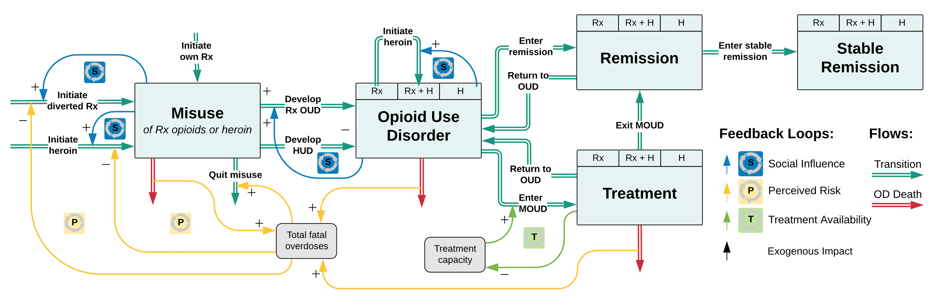

**Figure 1.** Overview of key transitions and feedback effects in model. See S2 for full structure.

# Results

[OSM] closely replicates the historical trajectory of the opioid crisis over 1999-2019 (**Figure 2**, and S5). Across all 15 time series used in model estimation, average R2 for simulated values against data is 0.758, while mean absolute errors normalized by mean (MAEN) are 12.2%. For total overdose deaths, R2=0.966 and MAEN=8.4%. The model’s ability to simultaneously replicate many different historical trajectories as a result of its endogenous structure gives confidence that this structure is a robust representation of the real system (*17*) (see also Model Validation below).

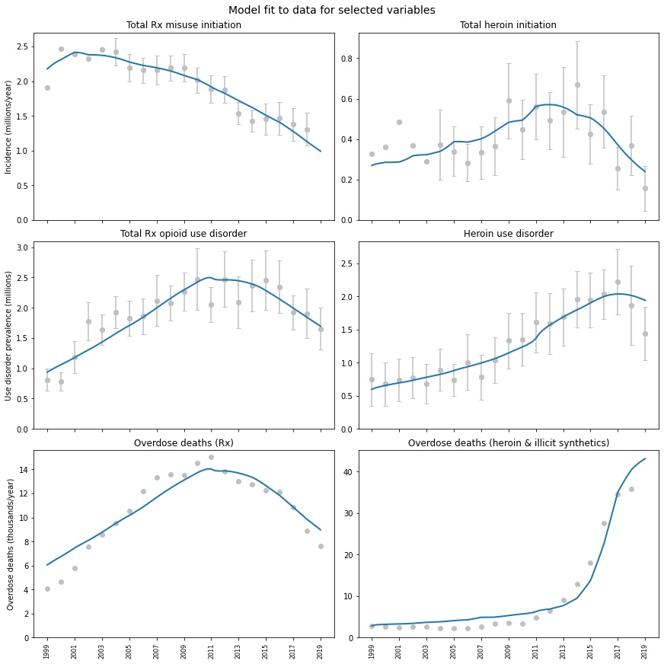

**Figure 2.** Comparison of simulated model output (blue) to historical data (grey, 95% confidence intervals where available) for selected time-series variables.

Note that ‘heroin’ implicitly includes IMF; see S2. Rx overdose deaths exclude heroin and IMF. Historical data sources: NSDUH (initiation, use disorder prevalence), NVSS (overdose deaths). Full results in S5.

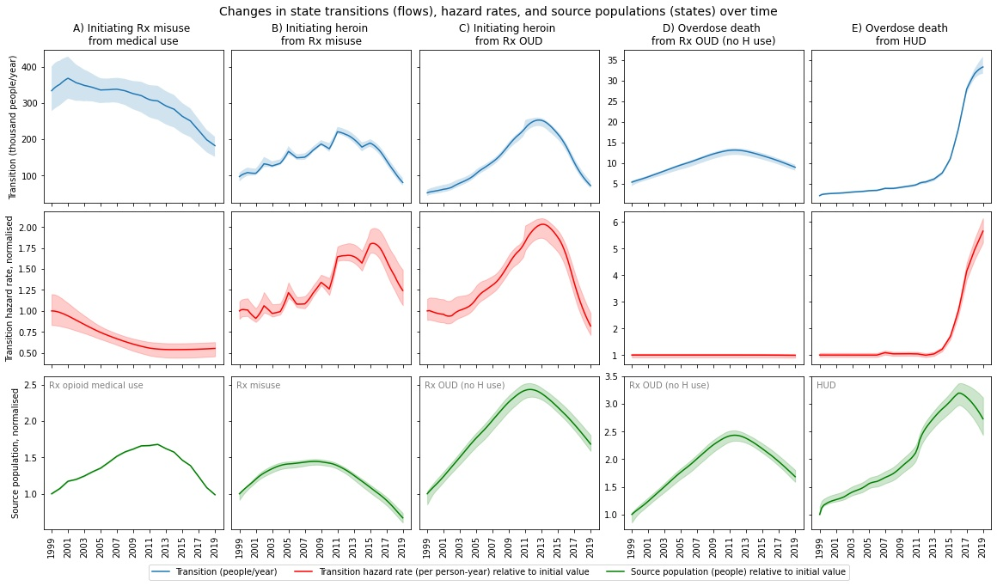

**Figure 3.** Changes in key transitions (flows) over time

(top, blue), distinguishing effects of changes in transition hazard rates (middle, red) and source populations (bottom, green). Bands are 95% credible intervals (CrIs). Source populations and hazard rates are normalized to their initial values. Rx=prescription opioid; Rx OUD=prescription opioid use disorder; HUD=heroin use disorder

### Shifting risks over time

[OSM] replicates the fluctuations over time of several key transitions between states (e.g., drug use initiation, overdose death)(**Figure 3**). These fluctuations result from changes in the sizes of populations at risk of each transition as the overall scale of the crisis has grown, and changes in the per-person-year hazard rates of transitions (i.e., transition probabilities/risks). Crucially, these risks or hazard rates are not static. But most existing models either represent them as constant over time, or vary them exogenously, without constraint, to fit historical data (*11*–*13*). [OSM]’s feedback and operational structure constrains how hazard rates evolve over time in relation to the state of the crisis, yielding an internally consistent understanding of shifting risk patterns.

For instance, prescription opioid misuse initiation from medical use has declined over time (**Figure 3A**, top). [OSM] attributes this decline primarily to a rapid fall in the per-person-year hazard of initiation in the 2000s (**Figure 3A**, middle), driven by a combination of growing perceived risk associated with opioid use and declining popularity (i.e., social influence). As a result, misuse initiation fell even as prescribing rates and the patient population receiving opioids (**Figure 3A**, bottom) continued to increase until around 2011. After 2011, falling prescribing rates played a role in the continued decline of misuse initiation as well.

In contrast, [OSM] estimates that hazard rates of heroin initiation from prior prescription opioid use (**Figure 3B-C**) rose through 2013, driven primarily by processes of social influence, before eventually falling as growing overdose deaths increased the perceived risk of heroin use. As a result, heroin initiation continued to rise even after prescription opioid misuse (**Figure 3B**) and prescription OUD (**Figure 3C**) peaked and fell earlier, around 2009-2011.

### Competing influences of naloxone and fentanyl

Risks and drivers of overdose mortality have evolved over time as well. Comparing fentanyl prevalence, naloxone distribution, and overdose mortality data, [OSM] estimates that overdose death hazard has remained relatively stable over time for people with prescription OUD who do not also use heroin/IMF (**Figure 3D**), though this could change as fentanyl-contaminated counterfeit pills spread (*18*, *19*). Among people who use heroin/IMF, however, overdose death hazard has shifted noticeably (**Figure 3E**), due to two growing and competing influences starting around 2013-2015 – increasing IMF presence in the heroin supply (*3*, *20*), followed by numerous efforts to increase access to the lifesaving overdose reversal drug naloxone (*21*).

On balance, overdose death hazard has increased substantially since 2014, as naloxone distribution to laypersons is not keeping pace with the growing mortality risk from IMF. Among people with HUD, who are both more exposed to illicit synthetics and more likely to receive naloxone (*22*), [OSM] estimates the overdose death hazard in 2019 would be 17.6% (90% credible interval (CrI): 9.4%-26.2%) higher absent naloxone distribution efforts. In the absence of illicit synthetics, however, it would be 85.0% (90%CrI: 83.9%-86.0%) lower.

Across all people who use opioids, we estimate 14,300 (90%CrI: 12,000-16,900) deaths averted due to layperson naloxone over the entire period from 1999-2019 (**Figure 4**), mostly in the last few years when naloxone distribution has increased rapidly. This estimate of layperson naloxone’s impact on overdose death hazard is broadly consistent with other existing estimates (*23*, *24*).

We also estimate that in a counterfactual situation where IMF were completely absent, there would have been 101,000 (90%CrI: 95,000-110,000) fewer overdose deaths from 1999-2019 (**Figure 4**). This estimate of the net impact of IMF on mortality is lower than the raw total of approximately 171,000 synthetic-opioid-involved overdose deaths reported in the National Vital Statistics System (NVSS) from 1999-2019 (*25*). There are two reasons for this difference. First, the raw total includes deaths from prescription as well as illicit fentanyl. Second, the raw data overestimate the true net mortality effect of IMF. [OSM] suggests that in reality, the fentanyl surge caused a rapid increase in the perceived risk associated with heroin use, which led to less heroin use by 2019 than there would have been otherwise. Absent the surge in mortality from IMF, an attenuated risk response would have meant higher ongoing initiation of heroin use in recent years, with attendant higher mortality. [OSM]’s estimate of net IMF impact reflects this attenuation.

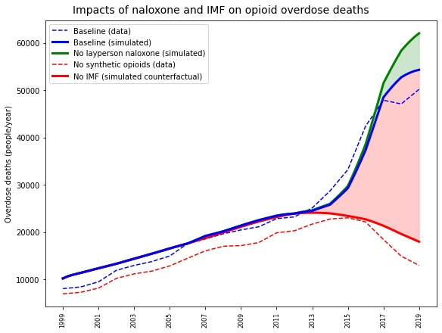

**Figure 4.** Comparison of impact of naloxone distribution and IMF on opioid overdose mortality

, showing total deaths averted due to layperson naloxone (green shading), and excess deaths due to IMF (red shading). Dashed lines (right) are observed data. Simulated deaths absent IMF (red, solid) are higher than reported deaths not involving synthetic opioids (red, dashed) – in earlier years, due to prescription fentanyl, and in later years, due to attenuated risk response in the counterfactual absence of IMF.

## Policy analysis process and baseline projections

Based on its historical estimates, [OSM] can project potential future trajectories of the opioid crisis for use in policy analysis. Any such projections require some baseline assumptions about future trends in exogenous model inputs. As a baseline, we consider an ‘exogenous trends continue’ (ETC) scenario where present trends in [OSM]’s exogenous inputs are assumed to continue at decelerating rates, stabilizing at plausible levels by 2031 (**Table 1**). The ETC case should not be considered a precise forecast, but rather a plausible future baseline in the absence of new policy interventions.

Under ETC assumptions, we project continued declines in the initiation and prevalence of prescription opioid misuse, heroin/IMF use, and OUD (**Figure 5**). Overdose mortality declines accordingly, though deaths continue to be high, with an additional 458,000 (90%CrI: 398,000-563,000) total overdose deaths from 2019-2031, as well as 27.0 (90%CrI: 24.3-31.7) million person-years of OUD.

**Table 1.** Exogenous input time series showing 2019 data values and 'ETC' (exogenous trends continue) case assumptions

|  |  |  |  |
| --- | --- | --- | --- |
| **Input** | **Source** | **2019** | **ETC 2031** |
| Patients receiving opioid analgesic prescription | IQVIA | 45.9 million | 29.3 million |
| Prescriptions per person | IQVIA | 3.37 | 3.34 |
| Average opioid MME per prescription | IQVIA | 779 | 531 |
| ADF fraction of prescribed opioids (% of MME) | IQVIA | 5.6% | 3.2% |
| Buprenorphine-waivered treatment providers | Various** | 66,800 | 168,000 |
| Methadone maintenance treatment capacity* | N-SSATS | 472,000 | 583,000 |
| Vivitrol® treatment capacity* | IQVIA | 36,600 | 45,600 |
| Naloxone kits distributed | IQVIA, various** | 1.93 million | 3.37 million |
| Heroin price index (1999 = 1) | UNODC, STRIDE | 0.54 | 0.54 |
| Fentanyl penetration | NFLIS | 47.3% | 70.7% |
| * MMT/Vivitrol capacity are calculated based on treatment utilization data from listed sources; see S3  ** See S3 for details | | | |

These declines are driven primarily by the continued influences of risk response feedbacks (see S6), which are already apparent in falling initiation rates, as outlined above. Projections from other models, formal or implicit, which do not account for these dynamic changes in initiation may miss the impending peak and decline, instead projecting continued growth in opioid overdose mortality (e.g., (*11*–*13*)).

These projections require two additional caveats. First, absent data for 2020, [OSM]’s estimates do not account for the impacts of the COVID-19 pandemic. Preliminary evidence indicates substantially increased overdose mortality in 2020 (*26*, *27*), likely due to a combination of reduced access to treatment and harm reduction services and the increased socioeconomic stressors from the pandemic. COVID-19 is the type of true exogenous shock unforeseeable in most models. We do not expect it to fundamentally alter the dynamics projected, though the transient increase in overdose mortality may lead to a later peak in mortality and higher cumulative impacts over several years than [OSM] projects.

Second, [OSM] does not account for the possibility of increasing contamination of stimulant supplies (e.g., cocaine, methamphetamine) with IMF (*28*) and consequent impacts on synthetic-opioid-involved overdoses (*29*, *30*), which could neutralize or even reverse projected declines in opioid overdose mortality.

Projected trends are largely insensitive to baseline input assumptions used, especially for major downstream outcomes such as overdose mortality and OUD prevalence (see S6 for tests of alternative base cases). The main source of sensitivity is assumptions about further IMF penetration in the illicit drug supply, which substantially influence projected overdose deaths. IMF’s presence in the supply of both illicit opioids and other drugs is expected to increase, but there is great uncertainty around just how much, how quickly, and where (*31*). Greater IMF penetration will not change the overall projected trend, but entails a larger rise in overdose mortality before it peaks (see S6). Given its outsize role in determining the future of the crisis, understanding the dynamics underlying the spread of IMF and identifying measures to curb it (or at least better monitor its presence) should be policy priorities.

[OSM] is currently undergoing beta-testing at FDA for use as a decision support tool, using its projections to analyze potential policy impacts and leveraging extensive sensitivity analysis to identify qualitatively robust policy options and key uncertainties. The model also provides a focal point for problem-structuring discussions with subject-matter experts and policymakers.

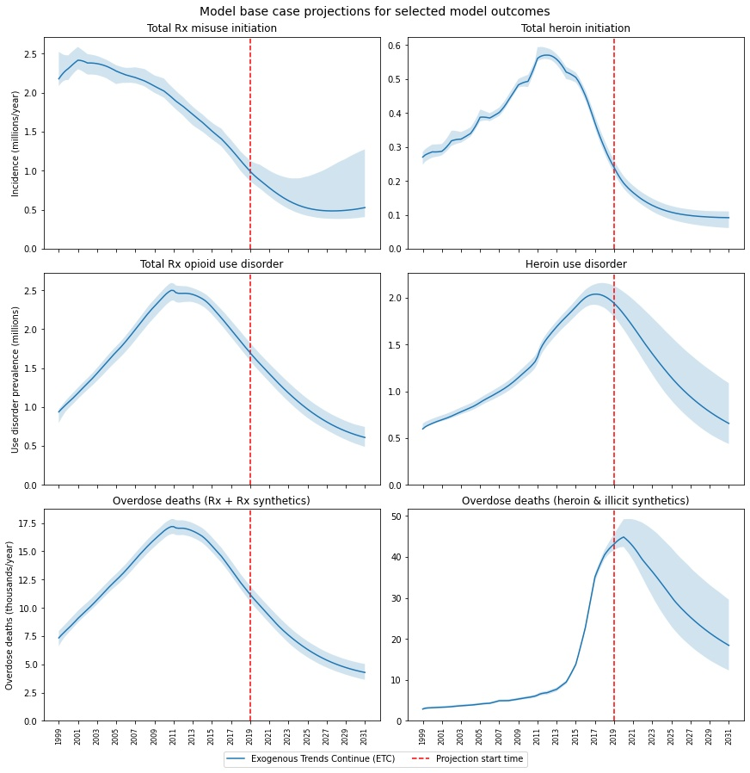

**Figure 5.** Simulated historical and projected trajectories for selected variables

, under ‘external trends continue’ (ETC) assumptions. Bands are 95% CrIs. Full results in S5.

## Limitations and areas for expansion

[OSM] has several limitations. First, the model necessarily relies on imperfect data (*8*). Much data around drug use is incomplete or suffers sampling bias. True longitudinal national-level data are not available. National-level data sources also do not report data on the growing problem of fentanyl (e.g., use, use disorder, overdose, treatment), preventing us from representing its effects other than on overdose and mortality. We have attempted to address some of these limitations (see S3), including correcting for established under-reporting of heroin use (*32*), and sensitivity testing can clarify the implications of uncertainties. Nevertheless, these shortcomings limit any model’s quantitative precision.

Second, [OSM] is a national-level model that aggregates over potentially important geographic and demographic heterogeneities. In part, this aggregation is due to data limitations; given more detailed data, the model could be parametrized for specific geographies (e.g., states) or demographics. Aggregation also provides computational tractability, allowing more extensive analysis and testing at the cost of some precision (*33*). Nonetheless, care must be taken to consider potentially important but hidden heterogeneities (*4*, *34*), particularly in the geography of fentanyl exposure (*31*).

Third, the model remains limited in scope. [OSM] currently lacks a unified outcome measure such as quality-adjusted life years (QALYs) or monetary cost that would allow more direct comparison of tradeoffs. Adding measures to enable use of [OSM] for cost-effectiveness analysis is the subject of ongoing FDA-funded work. [OSM] also does not address the growing and intertwined challenges of co-occurring stimulant use (*35*, *36*), counterfeit pharmaceuticals (*19*, *37*), and their interaction with IMF, which could drive a significant fraction of drug overdose mortality in coming years (*29*). It also does not address in detail the interaction of mental health comorbidities and other social determinants of health with substance use, nor does it account for untreated or undertreated pain. These topics are all major targets for potential further research. Additional work is under way to use [OSM] to analyze the outcomes of various intervention strategies, and an interactive simulation interface to allow rapid learning and experimentation is under development.

# Materials and Methods

This section summarizes model estimation, data sources, and testing; full details and documentation are in the supplementary materials, and all relevant files are publicly available at [LINK].

## Data sources

[OSM] includes 96 parameters, such as baseline hazard rates of state transitions (e.g., overdose, drug use initiation, relapse) and feedback effect sensitivities (see S5 for full list). Of these, 15 are derived from literature sources, 17 calculated from data, and 11 from expert input. Where possible, we synthesized multiple existing studies to derive parameter values, to address heterogeneity or non-representativeness of study populations (see S3). Tests of model sensitivity to parametric assumptions are presented in S6.

We formally estimated the remaining 53 parameters using a panel of national-level data from 1999-2019, drawn from both publicly available and proprietary nationally representative datasets, primarily the National Survey on Drug Use and Health, NVSS, and IQVIA (see S3). The panel includes annual initiation and prevalence of prescription opioid and heroin misuse and use disorder, patients receiving MOUD, and overdose mortality, as well as prescribing, treatment capacity, naloxone distribution, heroin prices, and fentanyl prevalence.

## Model estimation

The model uses 10 time series from the data panel as exogenous inputs, which correspond closely to real-world phenomena whose drivers are outside the model’s scope (**Table 1**).

We used the remainder of the data panel for formal model estimation, detailed in S4. Estimation is by maximum likelihood (*38*), using a Gaussian likelihood function to identify the set of parameter values that maximizes the likelihood of observing historical data given historical inputs and those parameter values.

We quantified uncertainties in parameter estimates using a Markov Chain Monte Carlo method intended for exploring high-dimensional parameter spaces (*39*). From the credible region of parameter space thus quantified, we generated a sub-sample of 5000 plausible alternative model specifications for use in sensitivity analysis, and as the basis for credible intervals on model projections.

## Model validation

[OSM]’s role in policy decision support demands high confidence in its structure, quantification, and projections. To establish confidence, we developed [OSM]’s structure through an iterative process of expert consultation, detailed in S3. In addition, [OSM] has been subject to multiple reviews by third-party consultants contracted by FDA to evaluate the model. Reviewers assessed the model against sound modelling principles and best practices, checking model behavior and reviewing parametric and structural assumptions.

We also validated our estimation framework using a synthetic data analysis, generating 20 artificial datasets statistically similar to historical data and attempting to recover ‘true’ parameter values using our estimation procedure. The absolute error between estimated and true parameter values was considerably smaller than the estimated uncertainty, and estimated credible intervals were close to their theoretically expected accuracies (see S4). Additional sensitivity analyses and robustness tests are presented in S6.

Finally, we recognize that both the opioid crisis itself, and our knowledge of it, continue to evolve; we will continue to update and revise [OSM] as more data emerge.

# References

1. H. Hedegaard, A. M. Miniño, M. Warner, “Drug Overdose Deaths in the United States, 1999-2019” (Hyattsville, MD, 2020), (available at https://www.cdc.gov/nchs/data/databriefs/db394-H.pdf).

2. H. Hedegaard, A. M. Miniño, M. Warner, “Drug Overdose Deaths in the United States, 1999-2019” (Hyattsville, MD, 2020).

3. D. Ciccarone, US Heroin in Transition: Supply Changes, Fentanyl Adulteration and Consequences. *Int. J. Drug Policy*. **46**, 107–111 (2017).

4. H. Jalal, J. M. Buchanich, M. S. Roberts, L. C. Balmert, K. Zhang, D. S. Burke, Changing dynamics of the drug overdose epidemic in the United States from 1979 through 2016. *Science (80-. ).* **361**, eaau1184 (2018).

5. National Academies of Sciences Engineering and Medicine, *Pain management and the opioid epidemic : balancing societal and individual benefits and risks of prescription opioid use* (The National Academies Press, Washington, DC, 2017; https://doi.org/10.17226/24781).

6. M. S. Jalali, M. Botticelli, R. C. Hwang, H. K. Koh, R. K. McHugh, The opioid crisis: need for systems science research. *Heal. Res. Policy Syst.* **18**, 88 (2020).

7. L. A. Lipsitz, Understanding health care as a complex system: The foundation for unintended consequences. *JAMA - J. Am. Med. Assoc.* **308** (2012), pp. 243–244.

8. M. S. Jalali, E. Ewing, C. B. Bannister, L. Glos, S. Eggers, T. Y. Lim, E. Stringfellow, C. A. Stafford, R. L. Pacula, H. Jalal, R. Kazemi-Tabriz, Data Needs in Opioid Systems Modeling: Challenges and Future Directions. *Am. J. Prev. Med.* **60**, e95–e105 (2021).

9. D. F. Musto, *The American Disease: Origins of narcotic control* (Oxford University Press, New York, NY, ed. 3rd, 1999).

10. C. P. Rydell, J. P. Caulkins, S. S. Everingham, Enforcement or Treatment? Modeling the Relative Efficacy of Alternatives for Controlling Cocaine. *Oper. Res.* **44**, 687–695 (1996).

11. A. L. Pitt, K. Humphreys, M. L. Brandeau, Modeling health benefits and harms of public policy responses to the US opioid epidemic. *Am. J. Public Health*. **108**, 1394–1400 (2018).

12. Q. Chen, M. R. Larochelle, D. T. Weaver, A. P. Lietz, P. P. Mueller, S. Mercaldo, S. E. Wakeman, K. A. Freedberg, T. J. Raphel, A. B. Knudsen, P. V. Pandharipande, J. Chhatwal, Prevention of Prescription Opioid Misuse and Projected Overdose Deaths in the United States. *JAMA Netw. Open*. **2**, e187621 (2019).

13. J. Ballreich, O. Mansour, E. Hu, F. Chingcuanco, H. A. Pollack, D. W. Dowdy, G. C. Alexander, Modeling Mitigation Strategies to Reduce Opioid-Related Morbidity and Mortality in the US. *JAMA Netw. Open*. **3**, e2023677 (2020).

14. J. Homer, W. Wakeland, A dynamic model of the opioid drug epidemic with implications for policy. *Am. J. Drug Alcohol Abuse*. **00**, 1–11 (2020).

15. B. P. Linas, A. Savinkina, R. W. M. A. Madushani, J. Wang, G. Eftekhari Yazdi, A. Chatterjee, A. Y. Walley, J. R. Morgan, R. L. Epstein, S. A. Assoumou, S. M. Murphy, B. R. Schackman, S. A. Chrysanthopoulou, L. F. White, J. A. Barocas, Projected Estimates of Opioid Mortality After Community-Level Interventions. *JAMA Netw. open*. **4**, e2037259 (2021).

16. M. A. Irvine, M. Kuo, J. A. Buxton, R. Balshaw, M. Otterstatter, L. Macdougall, M. J. Milloy, A. Bharmal, B. Henry, M. Tyndall, D. Coombs, M. Gilbert, Modelling the combined impact of interventions in averting deaths during a synthetic-opioid overdose epidemic. *Addiction*. **114**, 1602–1613 (2019).

17. R. Oliva, Model calibration as a testing strategy for system dynamics models. *Eur. J. Oper. Res.* **151**, 552–568 (2003).

18. Drug Enforcement Administration, “Counterfeit prescription pills containing fentanyls: A global threat” (Springfield, VA, 2016), (available at https://www.safemedicines.org/2018/06/fentanyl-has-created-a-new-kind-of-21st-century-drug-kingpin.html).

19. T. C. Green, M. Gilbert, Counterfeit medications and fentanyl. *JAMA Intern. Med.* **176**, 1555–1557 (2016).

20. Drug Enforcement Administration Diversion Control Division, “NFLIS Brief: Fentanyl, 2001-2015” (Springfield, VA, 2017).

21. SAMHSA, Grants to Prevent Prescription Drug/Opioid Overdose-Related Deaths. *FOA SP-16-005* (2016), (available at https://www.samhsa.gov/grants/grant-announcements/sp-16-005).

22. N. Fairbairn, P. O. Coffin, A. Y. Walley, Naloxone for heroin, prescription opioid, and illicitly made fentanyl overdoses: Challenges and innovations responding to a dynamic epidemic. *Int. J. Drug Policy*. **46**, 172–179 (2017).

23. M. A. Irvine, J. A. Buxton, M. Otterstatter, R. Balshaw, R. Gustafson, M. Tyndall, P. Kendall, T. Kerr, M. Gilbert, D. Coombs, Distribution of take-home opioid antagonist kits during a synthetic opioid epidemic in British Columbia, Canada: a modelling study. *Lancet Public Heal.* **3**, e218–e225 (2018).

24. R. B. Naumann, C. P. Durrance, S. I. Ranapurwala, A. E. Austin, S. Proescholdbell, R. Childs, S. W. Marshall, S. Kansagra, M. E. Shanahan, Impact of a community-based naloxone distribution program on opioid overdose death rates. *Drug Alcohol Depend.* **204**, 107536 (2019).

25. National Center for Health Statistics, Mortality Multiple Cause-of-Death Public Use Data Files and Documentation (2021), (available at https://www.cdc.gov/nchs/data_access/vitalstatsonline.htm#Mortality_Multiple).

26. Centers for Disease Control and Prevention, Overdose deaths accelerating during COVID-19 (2020), (available at https://www.cdc.gov/media/releases/2020/p1218-overdose-deaths-covid-19.html).

27. National Center for Health Statistics, Provisonal drug overdose deaths by quarter and demographic characteristics: United States 2018-Q1 through 2020-Q1 (2021), (available at https://www.cdc.gov/nchs/data/health_policy/Provisional-Drug-Overdose-Deaths-by-Quarter-Demographic-Characteristics-Q1-2020.pdf).

28. J. N. Park, E. Rashidi, K. Foti, M. Zoorob, S. Sherman, G. C. Alexander, Fentanyl and fentanyl analogs in the illicit stimulant supply: Results from U.S. drug seizure data, 2011–2016. *Drug Alcohol Depend.* **218**, 108416 (2021).

29. R. M. Gladden, J. O’Donnell, C. L. Mattson, P. Seth, Changes in Opioid-Involved Overdose Deaths by Opioid Type and Presence of Benzodiazepines, Cocaine, and Methamphetamine - 25 States, July-December 2017 to January-June 2018. *Morb. Mortal. Wkly. Rep.* **68**, 737–744 (2019).

30. P. DiSalvo, G. Cooper, J. Tsao, M. Romeo, L. K. Laskowski, G. Chesney, M. K. Su, Fentanyl-contaminated cocaine outbreak with laboratory confirmation in New York City in 2019. *Am. J. Emerg. Med.* **40**, 103–105 (2021).

31. M. Zoorob, Fentanyl shock: The changing geography of overdose in the United States. *Int. J. Drug Policy*. **70**, 40–46 (2019).

32. G. Midgette, S. Davenport, J. P. Caulkins, B. Kilmer, “What America’s Users Spend on Illegal Drugs, 2006-2016” (Santa Monica, CA, 2019), (available at https://www.whitehouse.gov/sites/default/files/ondcp/policy-and-research/wausid_technical_report.pdf).

33. H. Rahmandad, J. D. Sterman, Heterogeneity and Network Structure in the Dynamics of Diffusion: Comparing Agent-Based and Differential Equation Models. *Manage. Sci.* **54**, 998–1014 (2008).

34. G. J. Unick, D. Ciccarone, US regional and demographic differences in prescription opioid and heroin-related overdose hospitalizations. *Int. J. Drug Policy*. **46**, 112–119 (2017).

35. W. M. Compton, R. J. Valentino, R. L. DuPont, Polysubstance use in the U.S. opioid crisis. *Mol. Psychiatry*. **26** (2021), pp. 41–50.

36. T. J. Cicero, M. S. Ellis, Z. A. Kasper, Polysubstance use: A broader understanding of substance use during the opioid crisis. *Am. J. Public Health*. **110**, 244–250 (2020).

37. Drug Enforcement Administration, “Counterfeit prescription pills containing fentanyls: A global threat” (Springfield, VA, 2016).

38. J. Struben, J. D. Sterman, D. Keith, in *Analytical Methods for Dynamic Modelers*, H. Rahmandad, R. Oliva, N. D. Osgood, Eds. (MIT Press, Cambridge, MA, ed. 1st, 2015), pp. 3–38.

39. J. A. Vrugt, C. J. F. Ter Braak, C. G. H. Diks, B. A. Robinson, J. M. Hyman, D. Higdon, Accelerating Markov chain Monte Carlo simulation by differential evolution with self-adaptive randomized subspace sampling. *Int. J. Nonlinear Sci. Numer. Simul.* **10**, 271–288 (2009).

## Acknowledgements

This article reflects the views of the authors and should not be construed to represent the views or policies of the US Food and Drug Administration (FDA).

This project was supported in part by an appointment to the Research Participation Program at the Office of Program and Strategic Analysis, Center for Drug Evaluation and Research, U.S. Food and Drug Administration, administered by the Oak Ridge Institute for Science and Education through an interagency agreement between the U.S. Department of Energy and FDA.

Special thanks to Tom Fiddaman for access to pre-release versions of the parallelized Vensim® Engine.